Marshon Hughes
April 27th, 2026
CS-330-16418
Professor Aly
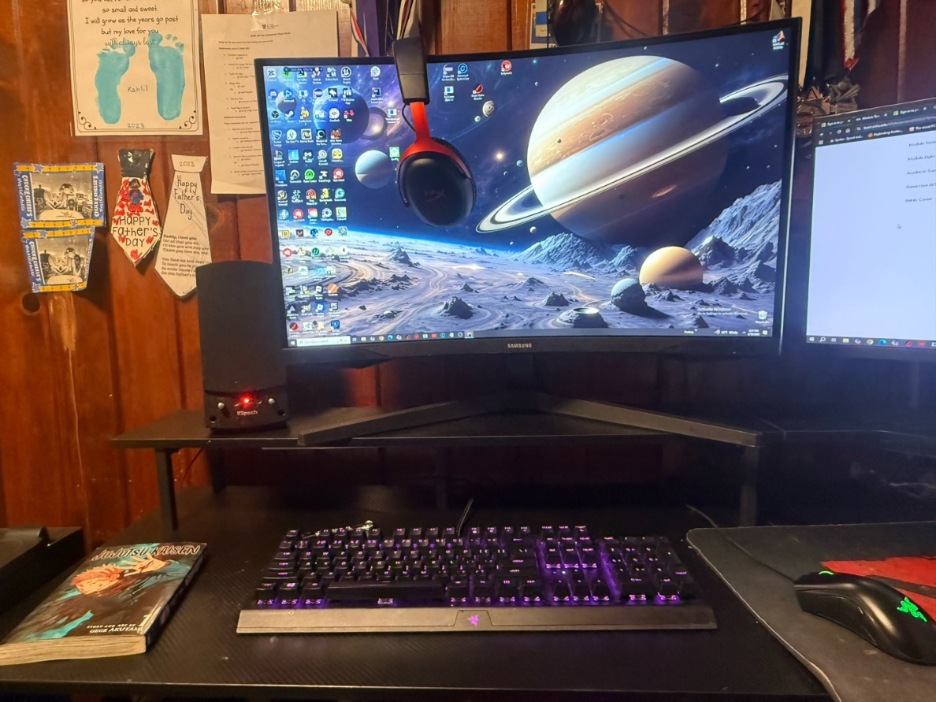
Milestone One: Final Project
The scene I will be recreating in a 3D space is a picture of my current office and gaming set up. The objects I chose to represent the scene would be the monitor, headset, speaker, keyboard, mouse, and book. Each of these items correlate with the office scenery, making it easy for the viewer to distinguish the theme of the scene. I also want to add a personal touch, which is why I wanted to add the manga. Not only do these items do a great job of representing my office space, but these items are composed of different basic 3D shapes that can illustrate how these shapes come together to make complex objects.
Most of these items can be created by utilizing basic 3D shapes. For example, I can use a plane to represent the desk or the bottom of the scene. Then, I can utilize a rectangular prism for the keyboard and use smaller boxes for the keys for the keyboard. But, if I have individual boxes for each one of the keys, the program will have to render a lot more shapes. I can represent the monitor with a rectangular prism, and a plane for the actual screen. Then I can implement three long rectangular prisms for the monitor stand. For the speaker, I can use a prism, with 2 smaller cylinders representing the knobs of the speaker. For the book can be represented with smaller rectangular prism, some smaller planes to represent the pages in the book. Finally, for the headphones I can utilize a short cylinder for the ear part of the headphones, then use multiple prisms for the piece that rests on your head. Finally, for the mouse, I can do a cylinder for the mouse wheel and a simple box for the actual mouse. I can also add buttons utilizing planes or smaller boxes.
To add realism to the scene, I also implemented different textures and lighting to give each object a certain look. To add textures, I had to ensure that the image was seamless, so you could not tell where the texture started or ended, also it was jpg, and the dimensions weren’t too small or large. Also, I adjusted the UV scaling to ensure the textures looked right on the object. Also, some of the texture materials have changed so it can showcase some of its properties. For example, the monitor screen is glossier, so it has a little more specular lighting than compared to the desk, which is more of a matte material, which has more diffused lighting than the monitor screen.
Users can navigate the 3D scene by utilizing the W key to move forward, S to move backwards, Q to move up, E to move down, A to move left, and D to move right. The user can also utilize the O key to change the perspective of the users view to an orthographic view and press the P key to change to perspective view. The users can also adjust the speed of the camera with the mouse wheel.
To help develop the scene, I utilized custom functions to make the program modular and organized. I made sure that I broke down the problem and made sure a function handles only that specific job. For example, a custom function I used was for setting the materials for the object in my scene. The function was responsible for controlling and defining different properties from the materials such as its ambient color, diffuse color, shininess, etc. It saved time, effort, and energy by being reusable. I can apply the same material to different objects without rewriting the whole material code every time.

